Security Assessment Report: CAPTCHA & Input Validation
Project: Web App Security Assessment
Date: Feb 10, 2026
Status: Final for Submission

Summary (with CWE)
During my testing of the user authentication and registration flows, I identified two main issues that allow for automated abuse of the system: a complete bypass of the CAPTCHA challenge and a lack of server-side input validation.
- CWE-804: CAPTCHA Bypass (The bot protection is essentially decorative).
- CWE-20: Improper Input Validation (The server trusts whatever the client sends).
While the frontend looks secure, the backend doesn't double-check the work. This means an attacker can sign up thousands of accounts or brute-force logins without solving a single puzzle.

Severity (calculate severity using CVSS)
I’ve rated this as 7.5 (High).
While this doesn't directly leak a database, it's a "force multiplier" for other attacks. By bypassing the CAPTCHA, an attacker can automate credential stuffing or spam the system, leading to significant data integrity issues and resource exhaustion.
Vector String: CVSS:3.1/AV:N/AC:L/PR:N/UI:N/S:U/C:N/I:H/A:N

Description

The CAPTCHA isn't actually being checked
The app uses a CAPTCHA to stop bots, but it's only a "suggestion" to the server. I found that I could simply delete the CAPTCHA parameter from the request, and the server would just process the login anyway. Even when I did solve it once, I could reuse that same "solution" over and over again. Usually, a CAPTCHA should expire the moment it's used; here, it stays valid indefinitely.

Trusting the Frontend too much
The web forms have rules (like "max 20 characters" or "must be an email"), but these rules only exist in the browser. By using a proxy to send requests directly to the server, I could ignore these rules entirely. I was able to send massive blocks of text and special characters that the UI normally blocks. This opens the door for more serious injection attacks later on.

Steps to reproduce
- Reconnaissance: Open the registration page and identify the CAPTCHA implementation.
- Proxy Setup: Fire up Burp Suite and turn on "Intercept."
- Submit Data: Fill out the registration form with valid data and click "Submit."
- Bypass CAPTCHA: * Locate the captcha field in the captured POST request.
  - Delete the parameter entirely or set it to an empty string "".
- Test Input Limits: * In the same request, modify the username field to include 5,000+ characters or HTML tags like <script>.
- Analyze Result: Forward the request and observe that the server returns a 200 OK, successfully creating the account or logging in despite the missing CAPTCHA and malformed input.

Screenshots

Figure 1: Initial Vulnerable Interface
Ref:
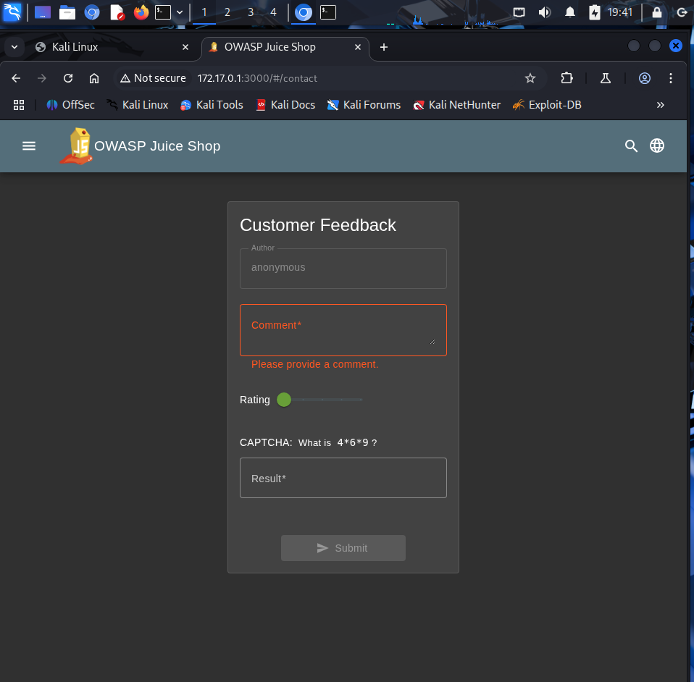
Target page showing the CAPTCHA challenge intended to prevent automated registrations.

Figure 2: Request Interception
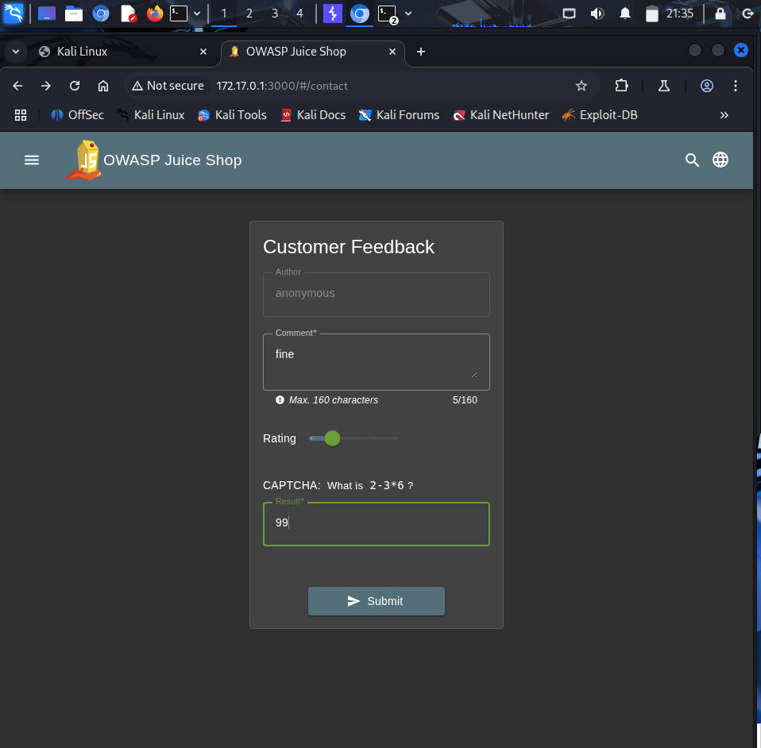
Ref: Capturing the raw HTTP POST request in Burp Suite before it reaches the server.

Figure 3: CAPTCHA Parameter Manipulation
Ref:
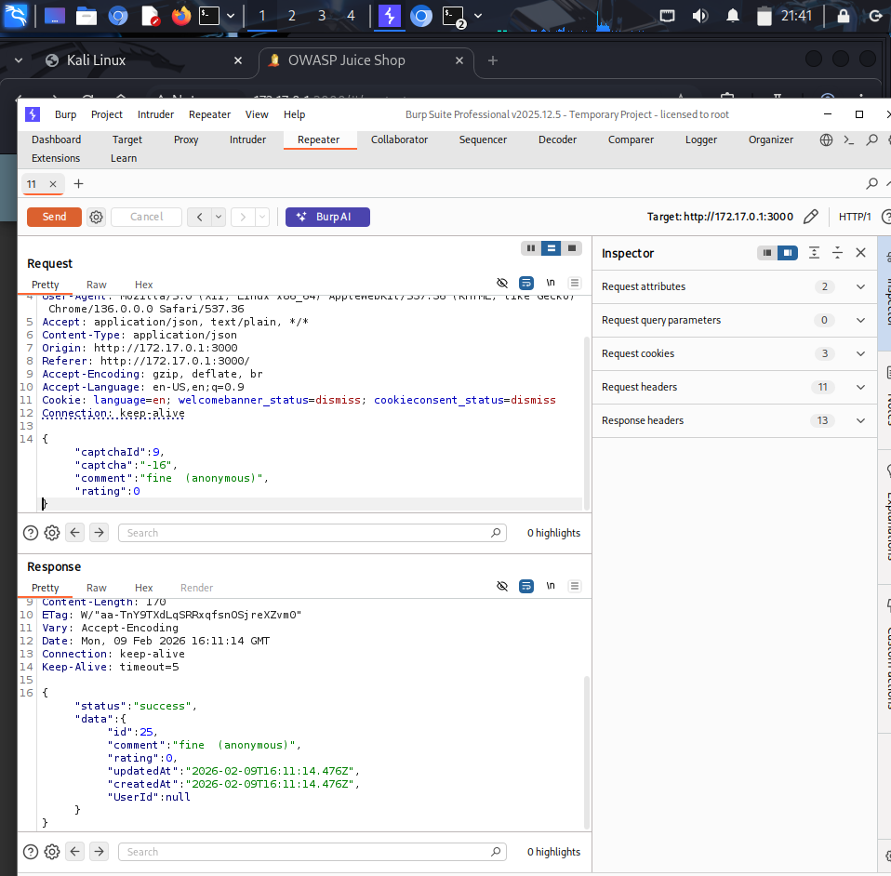
Removing the captcha token from the request body to test server-side enforcement.

Figure 4: Successful Bypass Response
Ref:
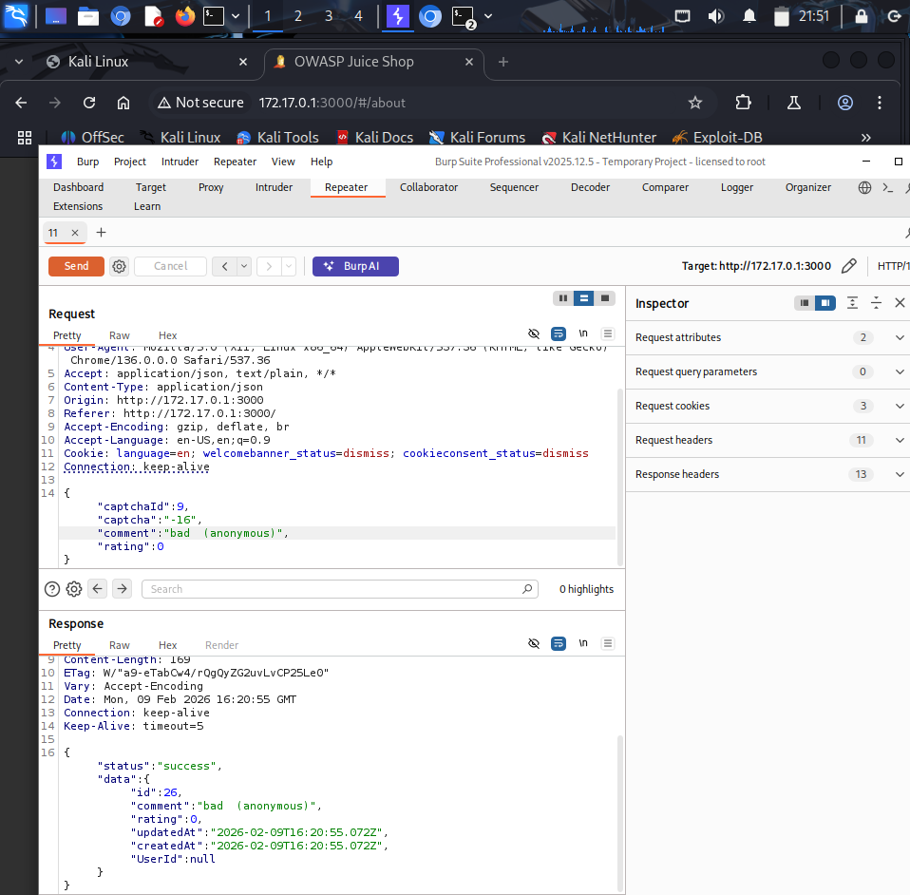
The server accepts the request without the CAPTCHA, returning a success status.

Figure 5: Automation via Intruder
Ref:
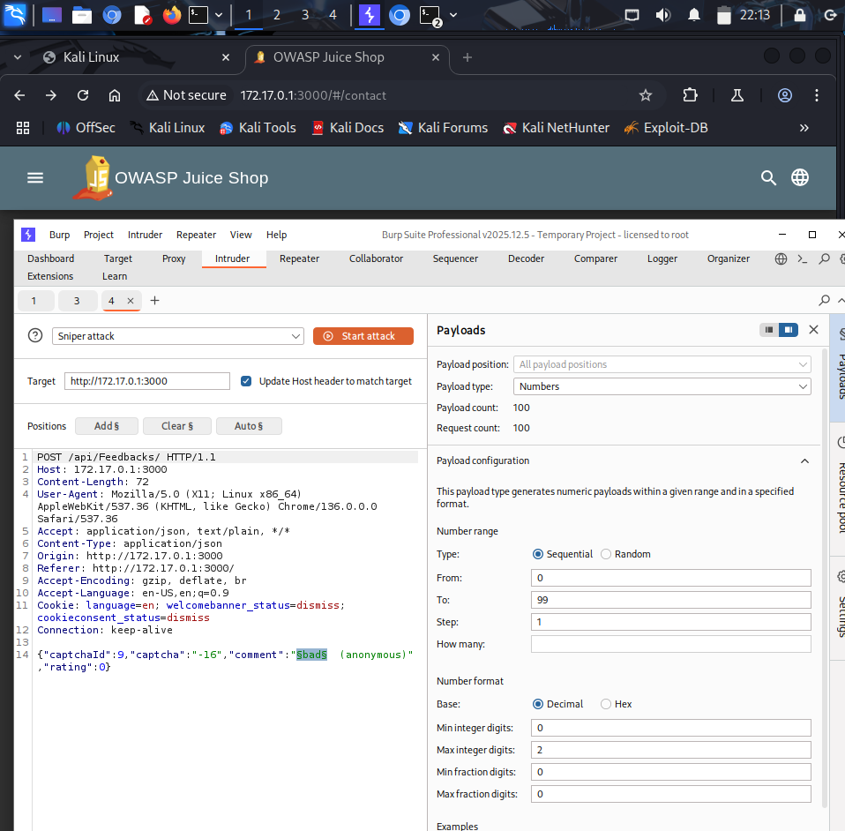
Automating 100+ registration attempts using the same CAPTCHA token; all requests were successful.

Figure 6: Input Validation Test (Length)
Ref:
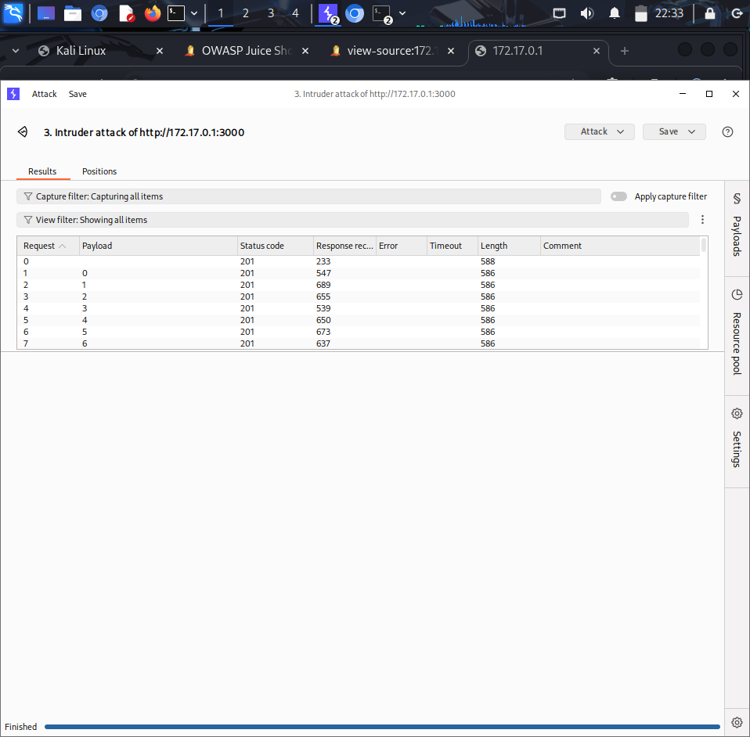
Submitting a payload that exceeds the frontend character limit, which the backend fails to catch.

Figure 7: Final Exploitation Success
Ref:
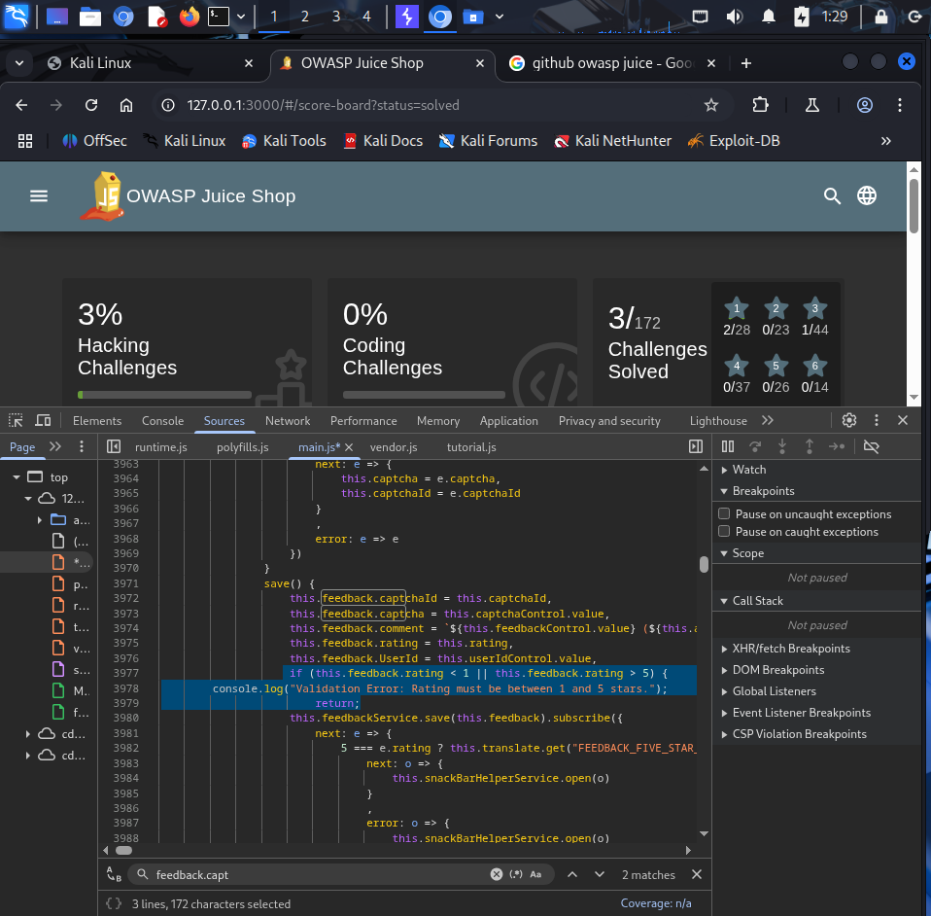
Confirmation of administrative access or account creation following the successful bypass.

Suggested remediation

Immediate fixes
- Mandatory Backend Verification: The server must reject any request that lacks a valid, verified CAPTCHA response.
- Token Expiration: Implement a "Burn-on-use" policy where tokens are invalidated immediately after one check.

Better long-term security
- Backend Validation: Implement strict length and type checks for every input field on the server-side (Allow-list approach).
- Upgrade CAPTCHA: Migrate to a behavior-based system like reCAPTCHA v3 or Cloudflare Turnstile.
- Rate Limiting: Throttle requests by IP to mitigate the speed of automated attacks even if a bypass is found.

References
- OWASP: Broken Access Control
- PortSwigger: CAPTCHA Bypass techniques
- CWE-20: Improper Input Validation

